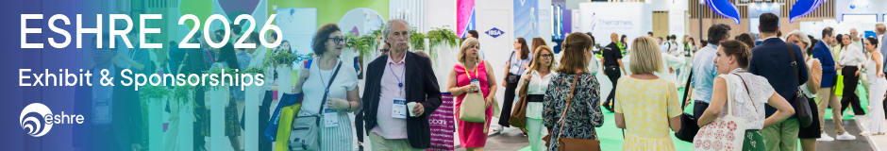

Dear Sir or Madam,

You are registered as an exhibitor for the ESHRE 42nd Hybrid Annual Meeting, which will take place in London, United Kingdom, from 5 to 8 July 2026.

Please use the following personal e-voucher code to complete your exhibitor registration:
[INSERT E-VOUCHER CODE]
Your registration will only be confirmed once you activate your e-voucher, so we recommend completing this step as soon as possible and before 19 June 2026.
Activation link: ESHRE 2026 e-voucher
To activate your e-voucher, log in with your personal login details and follow the steps.
ꙮ If you do not remember your password, you can reset it here:
Forgot password
ꙮ If you do not have an Eshre-account, please create one here: ESHRE

When activating your voucher, you will need to indicate whether you are a healthcare professional (HCP), non-health professional (Non-HCP) or other relevant decision maker (ORDM). You can find the definitions here: Definitions

Once your registration is complete, you will receive a confirmation letter with a barcode by email. You will need this barcode to obtain your badge onsite.
In case of any issues, please contact: registration@eshre.eu

With kind regards,
The exhibit team

